Appendix 5.3. Body map
Body maps must be used to record skin damage and can be applied as evidence if necessary at a later date. If two workers observed the skin damage they should both sign the body map.
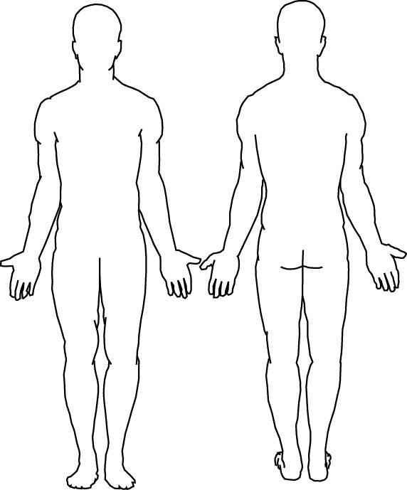

Name of first assessor
(PRINT)
Job Title |  | Signature
Name of second assessor (PRINT)
Job Title |  | Signature

Person Name: ………………………………………………………………….
Person Reference Number:……………………………………

